Implementare bazei de date

# Crearea bazei de date si a utilizatorilor

Pentru implementarea proiectului am avut nevoie de o baza de date OLTP centralizata pe care sa o distribuim in doua baze locale. Astfel am folosit doua baze de date fizice, care au fost definite pe o singura masina. Cele doua baze de date sunt MODBD1 si MODBD2.

## Utilizatori

In baza de date MODBD1 am definit 3 utilizatori:

* **modbd_centralizat**. In schema acestui utilizator este definite baza de date centralizata.
* **modbd_bucuresti**. In aceasta schema se afla una dintre cele doua baze de date locale.
* **modbd_national**. In schema utlizatorului national am definit view-uri pentru a putea interactiona cu ambele baze de date locale de la nivel “global”.

Au fost creati utilizatorii si atribuite drepturi de conectare.

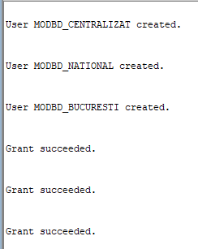create user modbd_centralizat identified by parolamodbd;

create user modbd_national identified by parolamodbd;

create user modbd_bucuresti identified by parolamodbd;

grant create session to modbd_centralizat;

grant resource to modbd_centralizat;

grant create session to modbd_national;

grant resource to modbd_national;

grant create session to modbd_bucuresti;

grant resource to modbd_bucuresti;

Au fost atribuite drepturi de creeare de legaturi intre baze de date utlizatorilor **modbd_national** si **modbd_bucuresti**:

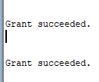grant CREATE PUBLIC DATABASE LINK to modbd_national;

grant DROP PUBLIC DATABASE LINK to modbd_national;

grant CREATE PUBLIC DATABASE LINK to modbd_bucuresti;

grant DROP PUBLIC DATABASE LINK to modbd_bucuresti;

Deoarece schemele utlizatorilor modbd_national si modbd_bucuresti sunt pe aceeasi baza de date fizica, desi BUCURESTI este considerata o baza de date locala utilizatorul modbd_national a primit depturi asupra tabelelor lui modbd_bucuresti.

grant select, insert, update, delete on modbd_bucuresti.PLATA_CHIRIE_BUCURESTI to modbd_national;

grant select, insert, update, delete on modbd_bucuresti.CONTRACT_BUCURESTI to modbd_national;

grant select, insert, update, delete on modbd_bucuresti.APARTAMENT_BUCURESTI to modbd_national;

grant select, insert, update, delete on modbd_bucuresti.AGENT_IMOBILIAR_BUCURESTI to modbd_national;

grant select, insert, update, delete on modbd_bucuresti.CHIRIAS to modbd_national;

grant select, insert, update, delete on modbd_bucuresti.JUDET_BUCURESTI to modbd_national;

grant select, insert, update, delete on modbd_bucuresti.LOCALITATE_BUCURESTI to modbd_national;

grant select, insert, update, delete on modbd_bucuresti.ADRESA_BUCURESTI to modbd_national;

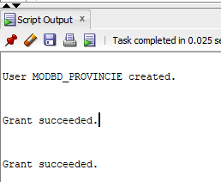In baza de date MODBD2 am definit utilizatorul **modbd_provincie**, care gazduieste cea de-a doua baza de date locala.

A fost definit utiliatorul si atribuite drepturi de conectare:

create user modbd_provincie identified by parolamodbd;

grant create session to modbd_provincie;

grant resource to modbd_provincie;

De asemenea, utilizatorul modbd_provincie a primit dreptul de a crea legaturi intre doua baze de date:



grant CREATE PUBLIC DATABASE LINK to modbd_provincie;

## Legaturi intre bazele de date

Pentru a putea comunica intre ele, pe cele doua baze de date au fost definite 4 legaturi:

* Provincie – Bucuresti

CREATE PUBLIC DATABASE LINK BD_BUCURESTI

CONNECT TO MODBD_BUCURESTI

IDENTIFIED BY parolamodbd

USING '(DESCRIPTION=

(ADDRESS=(PROTOCOL=TCP)(HOST=localhost)(PORT=1521))

(CONNECT_DATA=(SERVICE_NAME=modbd1))

)';



* Provincie – National

CREATE PUBLIC DATABASE LINK BD_CENTRALIZAT

CONNECT TO MODBD_CENTRALIZAT

IDENTIFIED BY parolamodbd

USING '(DESCRIPTION=

(ADDRESS=(PROTOCOL=TCP)(HOST=localhost)(PORT=1521))

(CONNECT_DATA=(SERVICE_NAME=modbd1))

)';



* National – Provincie

CREATE PUBLIC DATABASE LINK BD_PROVINCIE

CONNECT TO MODBD_PROVINCIE

IDENTIFIED BY parolamodbd

USING '(DESCRIPTION=

(ADDRESS=(PROTOCOL=TCP)(HOST=localhost)(PORT=1521))

(CONNECT_DATA=(SERVICE_NAME=modbd2))

)';



* Bucuresti – Provincie

CREATE PUBLIC DATABASE LINK BD_PROVINCIE

CONNECT TO MODBD_PROVINCIE

IDENTIFIED BY parolamodbd

USING '(DESCRIPTION=

(ADDRESS=(PROTOCOL=TCP)(HOST=localhost)(PORT=1521))

(CONNECT_DATA=(SERVICE_NAME=modbd2))

)';



# Crearea relatiilor si a fragmentelor

## Crearea bazei de date centralizate

*CREATE SEQUENCE OLTP_ADRESA_SEQ START WITH 1 INCREMENT BY 1;*

*CREATE SEQUENCE OLTP_LOCALITATE_SEQ START WITH 1 INCREMENT BY 1;*

*CREATE SEQUENCE OLTP_JUDET_SEQ START WITH 1 INCREMENT BY 1;*

*CREATE SEQUENCE OLTP_AGENT_IMOBILIAR_SEQ START WITH 1 INCREMENT BY 1;*

*CREATE SEQUENCE OLTP_CHIRIAS_SEQ START WITH 1 INCREMENT BY 1;*

*CREATE SEQUENCE OLTP_APARTAMENT_SEQ START WITH 1 INCREMENT BY 1;*

*CREATE SEQUENCE OLTP_CONTRACT_SEQ START WITH 1 INCREMENT BY 1;*

*CREATE SEQUENCE OLTP_PLATA_CHIRIE_SEQ START WITH 1 INCREMENT BY 1;*

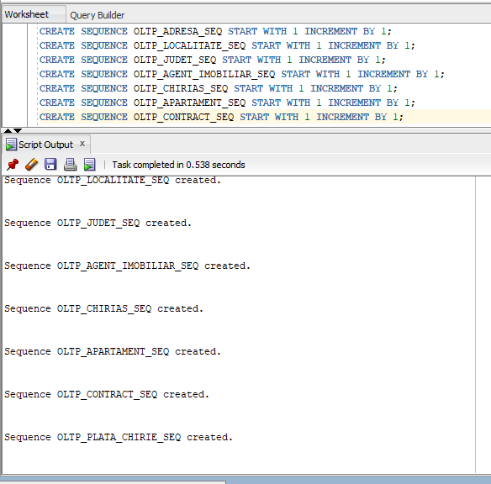

**Definirea tabelelor si a constrangerilor**

create table OLTP_JUDET

(

id_judet NUMBER(4) DEFAULT OLTP_JUDET_SEQ.NEXTVAL not null,

nume VARCHAR2(25)

)

;

alter table OLTP_JUDET

add constraint OLTP_JUD_ID_PK primary key (id_judet);

create index OLTP_JUD_NUME_IX on OLTP_JUDET (nume);

alter table OLTP_JUDET

add constraint OLTP_JUD_NUME_NN

check ("NUME" IS NOT NULL);

create table OLTP_LOCALITATE

(

id_localitate NUMBER(4) DEFAULT OLTP_LOCALITATE_SEQ.NEXTVAL not null,

nume VARCHAR2(25),

id_judet NUMBER(4) not null

)

;

alter table OLTP_LOCALITATE

add constraint OLTP_LOC_ID_PK primary key (id_localitate);

alter table OLTP_LOCALITATE

add constraint OLTP_LOC_OLTP_JUD_FK foreign key (id_judet)

references OLTP_JUDET (id_judet);

create index OLTP_LOC_NUME_IX on OLTP_LOCALITATE (nume);

alter table OLTP_LOCALITATE

add constraint OLTP_LOC_NUME_NN

check ("NUME" IS NOT NULL);

create table OLTP_ADRESA

(

id_adresa NUMBER(4) DEFAULT OLTP_ADRESA_SEQ.NEXTVAL not null,

strada VARCHAR2(40),

numar NUMBER(4),

bloc VARCHAR2(10),

scara VARCHAR2(5),

numar_apartament NUMBER(4),

id_localitate NUMBER(4) not null

)

;

alter table OLTP_ADRESA

add constraint OLTP_ADR_ID_PK primary key (id_adresa);

alter table OLTP_ADRESA

add constraint OLTP_ADR_OLTP_LOC_FK foreign key (id_localitate)

references OLTP_LOCALITATE (id_localitate);

create index OLTP_ADR_STRADA_IX on OLTP_ADRESA (strada);

alter table OLTP_ADRESA

add constraint OLTP_ADR_STRADA_NN

check ("STRADA" IS NOT NULL);

create table OLTP_AGENT_IMOBILIAR

(

id_agent NUMBER(6) DEFAULT OLTP_AGENT_IMOBILIAR_SEQ.NEXTVAL not null,

prenume VARCHAR2(20),

nume VARCHAR2(25),

email VARCHAR2(25),

telefon VARCHAR2(20),

data_angajare DATE,

salariu NUMBER(8,2),

comision NUMBER(2,2)

)

;

alter table OLTP_AGENT_IMOBILIAR

add constraint OLTP_AGENT_IMOBILIAR_ID_OLTP_AGENT_IMOBILIAR_PK primary key (ID_AGENT);

create index OLTP_AGENT_IMOBILIAR_NUME_IX on OLTP_AGENT_IMOBILIAR (NUME, PRENUME);

alter table OLTP_AGENT_IMOBILIAR

add constraint OLTP_AGENT_IMOBILIAR_EMAIL_UK unique (EMAIL);

alter table OLTP_AGENT_IMOBILIAR

add constraint OLTP_AGENT_IMOBILIAR_TELEFON_UK unique (TELEFON);

alter table OLTP_AGENT_IMOBILIAR

add constraint OLTP_AGENT_IMOBILIAR_DATA_OLTP_AGENT_IMOBILIAR_NN

check ("DATA_ANGAJARE" IS NOT NULL);

alter table OLTP_AGENT_IMOBILIAR

add constraint OLTP_AGENT_IMOBILIAR_EMAIL_NN

check ("EMAIL" IS NOT NULL);

alter table OLTP_AGENT_IMOBILIAR

add constraint OLTP_AGENT_IMOBILIAR_TELEFON_NN

check ("TELEFON" IS NOT NULL);

alter table OLTP_AGENT_IMOBILIAR

add constraint OLTP_AGENT_IMOBILIAR_NUME_NN

check ("NUME" IS NOT NULL);

alter table OLTP_AGENT_IMOBILIAR

add constraint OLTP_AGENT_IMOBILIAR_SALARIU_MIN

check (SALARIU > 0);

create table OLTP_CHIRIAS

(

id_chirias NUMBER(6) DEFAULT OLTP_CHIRIAS_SEQ.NEXTVAL not null,

prenume VARCHAR2(20),

nume VARCHAR2(20),

telefon VARCHAR2(20),

email VARCHAR2(30),

sex VARCHAR2(1),

data_nastere DATE,

starea_civila VARCHAR2(20)

)

;

alter table OLTP_CHIRIAS

add constraint OLTP_CHIRIAS_ID_OLTP_CHIRIAS_PK primary key (ID_CHIRIAS);

create index OLTP_CHIRIAS_NUME_IX on OLTP_CHIRIAS (NUME, PRENUME);

alter table OLTP_CHIRIAS

add constraint OLTP_CHR_NUME_NN

check (NUME IS NOT NULL);

alter table OLTP_CHIRIAS

add constraint OLTP_CHR_PRENUME_NN

check (PRENUME IS NOT NULL);

alter table OLTP_CHIRIAS

add constraint OLTP_CHR_EMAIL_NN

check (EMAIL IS NOT NULL);

alter table OLTP_CHIRIAS

add constraint OLTP_CHIRIAS_EMAIL_UK unique (EMAIL);

alter table OLTP_CHIRIAS

add constraint OLTP_CHIRIAS_TELEFON_UK unique (TELEFON);

create table OLTP_APARTAMENT

(

id_apartament NUMBER(4) DEFAULT OLTP_APARTAMENT_SEQ.NEXTVAL not null,

id_adresa NUMBER(4) not null unique,

numar_camere NUMBER(4),

etaj CHAR(1) not null,

suprafata NUMBER(4),

centrala_proprie CHAR(1) not null,

pret_inchiriere NUMBER(8, 2),

tip_confort NUMBER(4) -- confort 1, 2, 3

);

alter table OLTP_APARTAMENT

add constraint OLTP_APARTAMENT_ID_OLTP_APARTAMENT_PK primary key (ID_APARTAMENT);

alter table OLTP_APARTAMENT

add constraint OLTP_APT_OLTP_ADR_FK foreign key (ID_ADRESA)

references OLTP_ADRESA (ID_ADRESA);

alter table OLTP_APARTAMENT

add constraint OLTP_APARTAMENT_NR_CAMERE_MIN

check (numar_camere > 0);

alter table OLTP_APARTAMENT

add constraint OLTP_APARTAMENT_SUPRAFATA_MIN

check (suprafata > 0);

alter table OLTP_APARTAMENT

add constraint OLTP_APARTAMENT_PRET_MIN

check (pret_inchiriere > 0);

alter table OLTP_APARTAMENT

add constraint OLTP_APARTAMENT_CONFORT_IN

check (tip_confort in (1, 2, 3));

create table OLTP_CONTRACT

(

id_contract NUMBER(4) DEFAULT OLTP_CONTRACT_SEQ.NEXTVAL not null,

id_chirias NUMBER(4) not null,

id_apartament NUMBER(4) not null,

id_agent NUMBER(4) not null,

data_inceput DATE not null,

data_final DATE not null,

ziua_scadenta NUMBER(4) not null,

pret_inchiriere NUMBER(8, 2),

valoare_estimata NUMBER(8, 2),

incasari NUMBER(8, 2)

);

alter table OLTP_CONTRACT

add constraint OLTP_CONTRACT_AP_PK primary key (ID_CONTRACT);

alter table OLTP_CONTRACT

add constraint OLTP_CON_AP_ID_FK foreign key (ID_APARTAMENT)

references OLTP_APARTAMENT (ID_APARTAMENT);

alter table OLTP_CONTRACT

add constraint OLTP_CON_CH_ID_FK foreign key (ID_CHIRIAS)

references OLTP_CHIRIAS (ID_CHIRIAS);

alter table OLTP_CONTRACT

add constraint OLTP_CON_AG_ID_FK foreign key (ID_AGENT)

references OLTP_AGENT_IMOBILIAR (ID_AGENT);

alter table OLTP_CONTRACT

add constraint ZIUA_SCANDETA_CHECK

check (ziua_scadenta >= 1 and ziua_scadenta <= 31);

create table OLTP_PLATA_CHIRIE

(

id_plata NUMBER(4) DEFAULT OLTP_PLATA_CHIRIE_SEQ.NEXTVAL not null,

id_contract NUMBER(4) not null,

luna NUMBER(4),

an NUMBER(4),

suma NUMBER(8, 2) default 0,

data_efectuarii DATE not null,

nr_zile_intarziere NUMBER(2)

);

alter table OLTP_PLATA_CHIRIE

add constraint OLTP_PLATA_CHIRIE_PK primary key (ID_PLATA);

alter table OLTP_PLATA_CHIRIE

add constraint OLTP_PLATA_CHIRIE_CONTRACT_FK foreign key (ID_CONTRACT)

references OLTP_CONTRACT (ID_CONTRACT);

alter table OLTP_PLATA_CHIRIE

add constraint OLTP_PLATA_CHIRIE_AN_MINIM

check (an > 1970);

alter table OLTP_PLATA_CHIRIE

add constraint OLTP_PLATA_CHIRIE_VALORI_LUNA

check (luna >= 1 and luna <= 12);

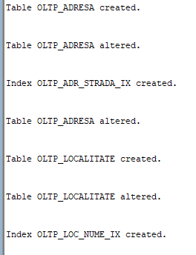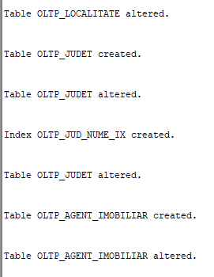

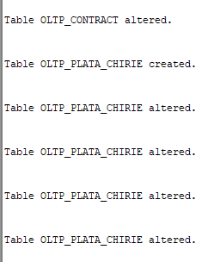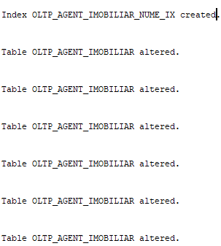

## Crearea bazelor de date locale

### Crearea bazei de date Bucuresti, crearea fragmentelor orizontale si stabilirea constrangerilor

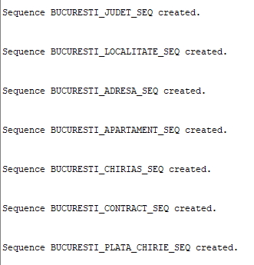 CREATE SEQUENCE BUCURESTI_JUDET_SEQ START WITH 43 INCREMENT BY 2;

CREATE SEQUENCE BUCURESTI_LOCALITATE_SEQ START WITH 149 INCREMENT BY 2;

CREATE SEQUENCE BUCURESTI_ADRESA_SEQ START WITH 169 INCREMENT BY 2;

CREATE SEQUENCE BUCURESTI_APARTAMENT_SEQ START WITH 153 INCREMENT BY 2;

CREATE SEQUENCE BUCURESTI_CHIRIAS_SEQ START WITH 99 INCREMENT BY 2;

CREATE SEQUENCE BUCURESTI_CONTRACT_SEQ START WITH 55 INCREMENT BY 2;

CREATE SEQUENCE BUCURESTI_PLATA_CHIRIE_SEQ START WITH 41 INCREMENT BY 2;

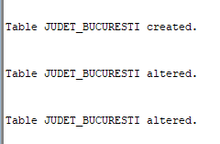--JUDET_BUCURESTI

create table JUDET_BUCURESTI as

select * from modbd_centralizat.oltp_judet

where nume = 'Bucuresti';

alter table JUDET_BUCURESTI

add constraint JUD_BUC_ID_PK primary key (id_judet);

alter table JUDET_BUCURESTI

add constraint JUD_BUCURESTI_NUME_NN

check ("NUME" IS NOT NULL);

--LOCALITATE_BUCURESTI

create table LOCALITATE_BUCURESTI as

select loc.*

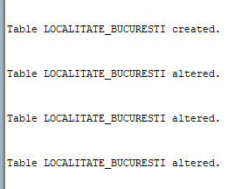from modbd_centralizat.oltp_localitate loc

join modbd_centralizat.oltp_judet jud on loc.id_judet = jud.id_judet

where jud.nume = 'Bucuresti';

alter table LOCALITATE_BUCURESTI

add constraint LOC_BUC_ID_PK primary key (id_localitate);

alter table LOCALITATE_BUCURESTI

add constraint LOC_BUC_JUD_FK foreign key (id_judet)

references JUDET_BUCURESTI (id_judet);

alter table LOCALITATE_BUCURESTI

add constraint LOC_BUC_NUME_NN check ("NUME" IS NOT NULL);

--ADRESA_BUCURESTI

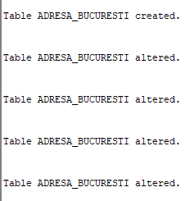create table ADRESA_BUCURESTI as

select adr.*

from modbd_centralizat.oltp_adresa adr

join modbd_centralizat.oltp_localitate loc on adr.id_localitate = loc.id_localitate

join modbd_centralizat.oltp_judet jud on loc.id_judet = jud.id_judet

where jud.nume = 'Bucuresti';

alter table ADRESA_BUCURESTI

add constraint ADR_BUC_ID_PK primary key (id_adresa);

alter table ADRESA_BUCURESTI

add constraint ADR_BUC_LOC_FK foreign key (id_localitate)

references LOCALITATE_BUCURESTI (id_localitate);

alter table ADRESA_BUCURESTI

add constraint ADR_BUC_STRADA_NN

check ("STRADA" IS NOT NULL);

alter table adresa_BUCURESTI

add constraint ADR_BUC_UNIQUE UNIQUE (STRADA, NUMAR, BLOC, SCARA, NUMAR_APARTAMENT);

--APARTAMENT_BUCURESTI

create table APARTAMENT_BUCURESTI as

select ap.*

from modbd_centralizat.oltp_apartament ap

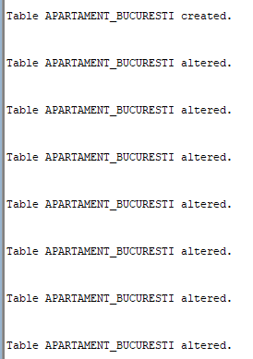join modbd_centralizat.oltp_adresa adr on ap.id_adresa = adr.id_adresa

join modbd_centralizat.oltp_localitate loc on adr.id_localitate = loc.id_localitate

join modbd_centralizat.oltp_judet jud on loc.id_judet = jud.id_judet

where jud.nume = 'Bucuresti';

alter table APARTAMENT_BUCURESTI

add constraint APARTAMENT_ID_BUC_APARTAMENT_PK primary key (ID_APARTAMENT);

alter table APARTAMENT_BUCURESTI

add constraint APT_BUC__ADR_FK foreign key (ID_ADRESA)

references ADRESA_BUCURESTI (ID_ADRESA);

alter table APARTAMENT_BUCURESTI

add constraint APARTAMENT_BUC_NR_CAMERE_MIN

check (numar_camere > 0);

alter table APARTAMENT_BUCURESTI

add constraint APARTAMENT_BUC_SUPRAFATA_MIN

check (suprafata > 0);

alter table APARTAMENT_BUCURESTI

add constraint APARTAMENT_BUC_PRET_MIN

check (pret_inchiriere > 0);

alter table APARTAMENT_BUCURESTI

add constraint APARTAMENT_BUC_CONFORT_IN

check (tip_confort in (1, 2, 3));

alter table APARTAMENT_BUCURESTI

add constraint APARTAMENT_BUC_ADR_UK UNIQUE (ID_ADRESA);

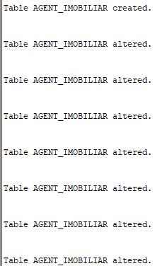--agent imobiliar

create table agent_imobiliar as

select id_agent, prenume, nume, email, telefon, data_angajare

from modbd_centralizat.oltp_agent_imobiliar;

alter table AGENT_IMOBILIAR

add constraint AGENT_IMOBILIAR_ID_AGENT_IMOBILIAR_PK primary key (ID_AGENT);

alter table AGENT_IMOBILIAR

add constraint AGENT_IMOBILIAR_EMAIL_UK unique (EMAIL);

alter table AGENT_IMOBILIAR

add constraint AGENT_IMOBILIAR_TELEFON_UK unique (TELEFON);

alter table AGENT_IMOBILIAR

add constraint AGENT_IMOBILIAR_DATA_AGENT_IMOBILIAR_NN

check ("DATA_ANGAJARE" IS NOT NULL);

alter table AGENT_IMOBILIAR

add constraint AGENT_IMOBILIAR_EMAIL_NN

check ("EMAIL" IS NOT NULL);

alter table AGENT_IMOBILIAR

add constraint AGENT_IMOBILIAR_TELEFON_NN

check ("TELEFON" IS NOT NULL);

alter table AGENT_IMOBILIAR

add constraint AGENT_IMOBILIAR_NUME_NN check ("NUME" IS NOT NULL);

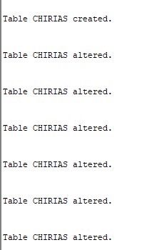-- CHIRIAS

create table chirias as

select * from modbd_centralizat.oltp_chirias;

alter table CHIRIAS

add constraint CHIRIAS_ID_CHIRIAS_PK primary key (ID_CHIRIAS);

alter table CHIRIAS

add constraint CHR_NUME_NN

check (NUME IS NOT NULL); alter table CHIRIAS

add constraint CHR_PRENUME_NN

check (PRENUME IS NOT NULL);

alter table CHIRIAS

add constraint CHR_EMAIL_NN

check (EMAIL IS NOT NULL);

alter table CHIRIAS

add constraint CHIRIAS_EMAIL_UK unique (EMAIL);

alter table CHIRIAS

add constraint CHIRIAS_TELEFON_UK unique (TELEFON);

--CONTRACT_BUCURESTI

create table CONTRACT_BUCURESTI AS

SELECT ID_CONTRACT, ID_CHIRIAS, con.ID_APARTAMENT, ID_AGENT, DATA_INCEPUT, DATA_FINAL, ZIUA_SCADENTA, con.PRET_INCHIRIERE, VALOARE_ESTIMATA, INCASARI

FROM modbd_centralizat.oltp_contract con

join modbd_centralizat.oltp_apartament ap on con.id_apartament = ap.id_apartament

join modbd_centralizat.oltp_adresa adr on ap.id_adresa = adr.id_adresa

join modbd_centralizat.oltp_localitate loc on adr.id_localitate = loc.id_localitate

where loc.nume = 'Bucuresti';

alter table CONTRACT_BUCURESTI

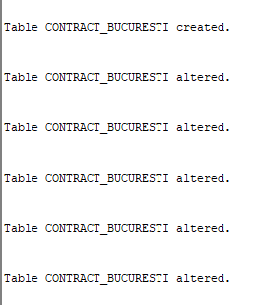 add constraint CONTRACT_BUC_AP_PK primary key (ID_CONTRACT);

alter table CONTRACT_BUCURESTI

add constraint CON_BUC_AP_ID_FK foreign key (ID_APARTAMENT)

references APARTAMENT_BUCURESTI (ID_APARTAMENT);

alter table CONTRACT_BUCURESTI

add constraint CONTRACT_BUC__CH_ID_FK foreign key (ID_CHIRIAS)

references CHIRIAS (ID_CHIRIAS);

alter table CONTRACT_BUCURESTI

add constraint CONTRACT_BUC_AG_ID_FK foreign key (ID_AGENT)

references AGENT_IMOBILIAR (ID_AGENT);

alter table CONTRACT_BUCURESTI

add constraint ZIUA_SCANDETA_CHECK

check (ziua_scadenta >= 1 and ziua_scadenta <= 31);

--PLATA_CHIRIE_BUCURESTI

create table PLATA_CHIRIE_BUCURESTI as

SELECT ID_PLATA, pc.ID_CONTRACT, LUNA, AN, SUMA, DATA_EFECTUARII, NR_ZILE_INTARZIERE

FROM modbd_centralizat.OLTP_PLATA_CHIRIE pc

join modbd_centralizat.oltp_contract con on pc.id_contract = con.id_contract

join modbd_centralizat.oltp_apartament ap on con.id_apartament = ap.id_apartament

join modbd_centralizat.oltp_adresa adr on ap.id_adresa = adr.id_adresa

join modbd_centralizat.oltp_localitate loc on adr.id_localitate = loc.id_localitate

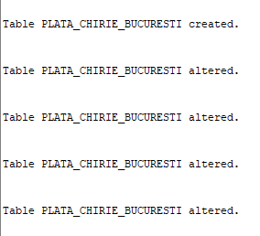where loc.nume = 'Bucuresti';

alter table PLATA_CHIRIE_BUCURESTI

add constraint PLATA_CHIRIE_BUC_CHIRIE_PK primary key (ID_PLATA);

alter table PLATA_CHIRIE_BUCURESTI

add constraint PLATA_CHIRIE_BUC_CHIRIE_CONTRACT_FK foreign key (ID_CONTRACT)

references CONTRACT_BUCURESTI (ID_CONTRACT);

alter table PLATA_CHIRIE_BUCURESTI

add constraint PLATA_CHIRIE_BUC_CHIRIE_AN_MINIM

check (an > 1970);

alter table PLATA_CHIRIE_BUCURESTI

add constraint PLATA_CHIRIE_BUC_CHIRIE_VALORI_LUNA

check (luna >= 1 and luna <= 12);

### Crearea bazei de date Provincie, crearea fragmentelor orizontale si stabilirea constrangerilor

CREATE SEQUENCE PROVINCIE_JUDET_SEQ START WITH 44 INCREMENT BY 2;

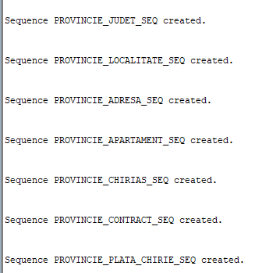 CREATE SEQUENCE PROVINCIE_LOCALITATE_SEQ START WITH 148 INCREMENT BY 2;

CREATE SEQUENCE PROVINCIE_ADRESA_SEQ START WITH 168 INCREMENT BY 2;

CREATE SEQUENCE PROVINCIE_APARTAMENT_SEQ START WITH 152 INCREMENT BY 2;

CREATE SEQUENCE PROVINCIE_CHIRIAS_SEQ START WITH 98 INCREMENT BY 2;

CREATE SEQUENCE PROVINCIE_CONTRACT_SEQ START WITH 56 INCREMENT BY 2;

CREATE SEQUENCE PROVINCIE_PLATA_CHIRIE_SEQ START WITH 42 INCREMENT BY 2;

--JUDET_PROVINCIE

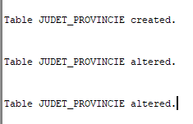create table JUDET_PROVINCIE as

select * from oltp_judet@BD_CENTRALIZAT

where nume <> 'Bucuresti';

alter table JUDET_PROVINCIE

add constraint JUD_PROV_ID_PK primary key (id_judet);

alter table JUDET_PROVINCIE

add constraint JUD_PROVINCIE_NUME_NN

check ("NUME" IS NOT NULL);

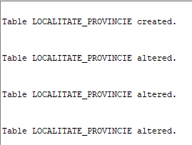--LOCALITATE_PROVINCIE

create table LOCALITATE_PROVINCIE as

select loc.*

from oltp_localitate@BD_CENTRALIZAT loc

join oltp_judet@BD_CENTRALIZAT jud on loc.id_judet = jud.id_judet

where jud.nume <> 'Bucuresti';

alter table LOCALITATE_PROVINCIE

add constraint LOC_PROV_ID_PK primary key (id_localitate);

alter table LOCALITATE_PROVINCIE

add constraint LOC_PROV_JUD_FK foreign key (id_judet)

references JUDET_PROVINCIE (id_judet);

alter table LOCALITATE_PROVINCIE

add constraint LOC_PROV_NUME_NN

check ("NUME" IS NOT NULL);

--ADRESA_PROVINCIE

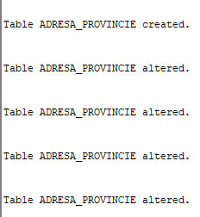create table ADRESA_PROVINCIE as

select adr.*

from oltp_adresa@BD_CENTRALIZAT adr

join oltp_localitate@BD_CENTRALIZAT loc on adr.id_localitate = loc.id_localitate

join oltp_judet@BD_CENTRALIZAT jud on loc.id_judet = jud.id_judet

where jud.nume <> 'Bucuresti';

alter table ADRESA_PROVINCIE

add constraint ADR_PROV_ID_PK primary key (id_adresa);

alter table ADRESA_PROVINCIE

add constraint ADR_PROV_LOC_FK foreign key (id_localitate)

references LOCALITATE_PROVINCIE (id_localitate);

alter table ADRESA_PROVINCIE

add constraint ADR_PROV_STRADA_NN

check ("STRADA" IS NOT NULL);

alter table adresa_provincie

add constraint ADR_PROV_UNIQUE UNIQUE (STRADA, NUMAR, BLOC, SCARA, NUMAR_APARTAMENT);

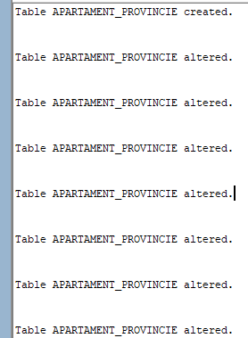--APARTAMENT_PROVINCIE

create table APARTAMENT_PROVINCIE as

select ap.*

from oltp_apartament@BD_CENTRALIZAT ap

join oltp_adresa@BD_CENTRALIZAT adr on ap.id_adresa = adr.id_adresa

join oltp_localitate@BD_CENTRALIZAT loc on adr.id_localitate = loc.id_localitate

join oltp_judet@BD_CENTRALIZAT jud on loc.id_judet = jud.id_judet

where jud.nume <> 'Bucuresti';

alter table APARTAMENT_PROVINCIE

add constraint APARTAMENT_ID_PROV_APARTAMENT_PK primary key (ID_APARTAMENT);

alter table APARTAMENT_PROVINCIE

add constraint APT_PROV__ADR_FK foreign key (ID_ADRESA)

references ADRESA_PROVINCIE (ID_ADRESA);

alter table APARTAMENT_PROVINCIE

add constraint APARTAMENT_PROV_NR_CAMERE_MIN

check (numar_camere > 0);

alter table APARTAMENT_PROVINCIE

add constraint APARTAMENT_PROV_SUPRAFATA_MIN

check (suprafata > 0);

alter table APARTAMENT_PROVINCIE

add constraint APARTAMENT_PROV_PRET_MIN

check (pret_inchiriere > 0);

alter table APARTAMENT_PROVINCIE

add constraint APARTAMENT_PROV_CONFORT_IN

check (tip_confort in (1, 2, 3));

alter table APARTAMENT_PROVINCIE

add constraint APARTAMENT_PROV_ADR_UK UNIQUE (ID_ADRESA);

--agent_imobiliar

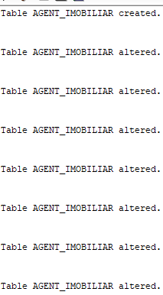create table agent_imobiliar as

select id_agent, prenume, nume, email, telefon, data_angajare

from oltp_agent_imobiliar@BD_CENTRALIZAT;

alter table AGENT_IMOBILIAR

add constraint AGENT_IMOBILIAR_ID_AGENT_IMOBILIAR_PK primary key (ID_AGENT);

alter table AGENT_IMOBILIAR

add constraint AGENT_IMOBILIAR_EMAIL_UK unique (EMAIL);

alter table AGENT_IMOBILIAR

add constraint AGENT_IMOBILIAR_TELEFON_UK unique (TELEFON);

alter table AGENT_IMOBILIAR

add constraint AGENT_IMOBILIAR_DATA_AGENT_IMOBILIAR_NN

check ("DATA_ANGAJARE" IS NOT NULL);

alter table AGENT_IMOBILIAR

add constraint AGENT_IMOBILIAR_EMAIL_NN

check ("EMAIL" IS NOT NULL);

alter table AGENT_IMOBILIAR

add constraint AGENT_IMOBILIAR_TELEFON_NN check ("TELEFON" IS NOT NULL);

alter table AGENT_IMOBILIAR add constraint AGENT_IMOBILIAR_NUME_NN check ("NUME" IS NOT NULL);

-- CHIRIAS

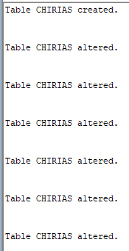create table chirias as

select * from oltp_chirias@BD_CENTRALIZAT;

alter table CHIRIAS

add constraint CHIRIAS_ID_CHIRIAS_PK primary key (ID_CHIRIAS);

alter table CHIRIAS

add constraint CHR_NUME_NN

check (NUME IS NOT NULL);

alter table CHIRIAS

add constraint CHR_PRENUME_NN

check (PRENUME IS NOT NULL);

alter table CHIRIAS

add constraint CHR_EMAIL_NN

check (EMAIL IS NOT NULL);

alter table CHIRIAS

add constraint CHIRIAS_EMAIL_UK unique (EMAIL);

alter table CHIRIAS

add constraint CHIRIAS_TELEFON_UK unique (TELEFON);

--CONTRACT_PROVINCIE

create table CONTRACT_PROVINCIE AS

SELECT ID_CONTRACT, ID_CHIRIAS, con.ID_APARTAMENT, ID_AGENT, DATA_INCEPUT, DATA_FINAL, ZIUA_SCADENTA, con.PRET_INCHIRIERE, VALOARE_ESTIMATA, INCASARI

FROM oltp_contract@BD_CENTRALIZAT con

join oltp_apartament@BD_CENTRALIZAT ap on con.id_apartament = ap.id_apartament

join oltp_adresa@BD_CENTRALIZAT adr on ap.id_adresa = adr.id_adresa

join oltp_localitate@BD_CENTRALIZAT loc on adr.id_localitate = loc.id_localitate

where loc.nume <> 'Bucuresti';

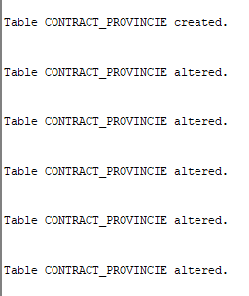alter table CONTRACT_PROVINCIE

add constraint CONTRACT_PROV_AP_PK primary key (ID_CONTRACT);

alter table CONTRACT_PROVINCIE

add constraint CON_PROV_AP_ID_FK foreign key (ID_APARTAMENT)

references APARTAMENT_PROVINCIE (ID_APARTAMENT);

alter table CONTRACT_PROVINCIE

add constraint CONTRACT_PROV__CH_ID_FK foreign key (ID_CHIRIAS)

references CHIRIAS (ID_CHIRIAS);

alter table CONTRACT_PROVINCIE

add constraint CONTRACT_PROV_AG_ID_FK foreign key (ID_AGENT)

references AGENT_IMOBILIAR (ID_AGENT);

alter table CONTRACT_PROVINCIE

add constraint ZIUA_SCANDETA_CHECK

check (ziua_scadenta >= 1 and ziua_scadenta <= 31);

--PLATA_CHIRIE_PROVINCIE

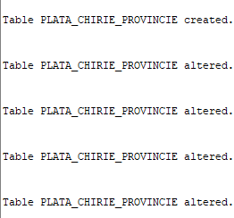create table PLATA_CHIRIE_PROVINCIE as

SELECT ID_PLATA, pc.ID_CONTRACT, LUNA, AN, SUMA, DATA_EFECTUARII, NR_ZILE_INTARZIERE

FROM OLTP_PLATA_CHIRIE@BD_CENTRALIZAT pc

join oltp_contract@BD_CENTRALIZAT con on pc.id_contract = con.id_contract

join oltp_apartament@BD_CENTRALIZAT ap on con.id_apartament = ap.id_apartament

join oltp_adresa@BD_CENTRALIZAT adr on ap.id_adresa = adr.id_adresa

join oltp_localitate@BD_CENTRALIZAT loc on adr.id_localitate = loc.id_localitate

where loc.nume <> 'Bucuresti';

alter table PLATA_CHIRIE_PROVINCIE

add constraint PLATA_CHIRIE_PROV_CHIRIE_PK primary key (ID_PLATA);

alter table PLATA_CHIRIE_PROVINCIE

add constraint PLATA_CHIRIE_PROV_CHIRIE_CONTRACT_FK foreign key (ID_CONTRACT)

references CONTRACT_PROVINCIE (ID_CONTRACT);

alter table PLATA_CHIRIE_PROVINCIE

add constraint PLATA_CHIRIE_PROV_CHIRIE_AN_MINIM

check (an > 1970);

alter table PLATA_CHIRIE_PROVINCIE

add constraint PLATA_CHIRIE_PROV_CHIRIE_VALORI_LUNA

check (luna >= 1 and luna <= 12);

### Fragmentarea tabelului OLTP_AGENT_IMOBILIAR

Dupa cum se poate observa din create-urile de mai sus pentru tabelele AGENT_IMOBILIAR din Provincie sau Bucuresti, lipsesc coloanele SALARIU si COMISION. Aceste date sunt stocate in schema utilizatorului modbd_national, si reprezinta un fragment vertical al tabelului OLTP_AGENT_IMOBILIAR.

create table AGENT_IMOBILIAR as

select id_agent, salariu, comision from modbd_centralizat.oltp_agent_imobiliar;

alter table AGENT_IMOBILIAR

add constraint AGENT_IMOBILIAR_ID_AGENT_IMOBILIAR_NATIONAL_PK primary key (ID_AGENT);

alter table AGENT_IMOBILIAR

add constraint AGENT_IMOBILIAR_SALARIU_MIN

check (SALARIU > 0);

alter table AGENT_IMOBILIAR

add constraint AGENT_IMOBILIAR_COMISION_MIN

check (comision >= 0);

Pentru a genera id-uri unice la nivel de angent se va folosit doar o secventa definite la nivel global.

CREATE SEQUENCE NATIONAL_AGENT_IMOBILIAR_SEQ START WITH 72 INCREMENT BY 1;

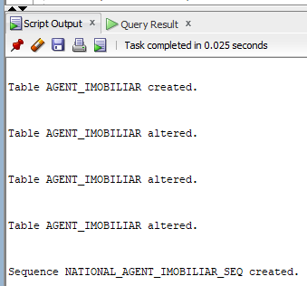

# Popularea cu date a bazelor de date

**Popularea bazei de date centralizata.**

Pentru baza de date centralizata au fost definite insert-uri pentru fiecare tabel in parte care folosesc secvente pentru generarea id-urilor unice.

insert into oltp_AGENT_IMOBILIAR values (oltp_AGENT_IMOBILIAR_SEQ.NEXTVAL, 'Andrei', 'Popa', 'george_1@gmail.com', '0723456789', to_date('12.05.2001', 'dd-mm-yyyy'), 3000, 0.15);

insert into oltp_CHIRIAS values (oltp_CHIRIAS_SEQ.NEXTVAL, 'Cristian', 'Olteanu', '0712345678', 'george@gmail.com', 'M', to_date('12.05.2000', 'dd-mm-yyyy'), 'singur');

INSERT INTO oltp_JUDET VALUES (oltp_JUDET_SEQ.NEXTVAL, 'Alba');

INSERT INTO oltp_LOCALITATE VALUES (oltp_LOCALITATE_SEQ.NEXTVAL, 'Alba Iulia', 1);

insert into oltp_ADRESA values (oltp_ADRESA_SEQ.NEXTVAL, 'Strada Primaverii', 12, 'Bl. C', 'Sc. A', 3, 2);

insert into oltp_APARTAMENT values (oltp_APARTAMENT_SEQ.NEXTVAL, 1, 2, '1', 65, 'Y', 2500, 2);

INSERT into oltp_CONTRACT values (oltp_CONTRACT_SEQ.NEXTVAL, 34, 23, 12, to_date('01-01-2002', 'dd-mm-yyyy'), to_date('31-12-2002', 'dd-mm-yyyy'), 5, null, null, 0);

INSERT INTO oltp_plata_chirie VALUES (oltp_plata_chirie_SEQ.NEXTVAL, 1, 1, 2000, 1800, to_date('01-01-2000', 'dd-mm-yyyy'), 1);

**Popularea bazelor de date locale.**

Popularea fragmentelor bazei de date centralizate se face la fragmentarea tabelelor din baza de date centralizata.

# Furnizarea formelor de transparenta

## Transparenta pentru fragmentele verticale

Tabelul OLTP_AGENT_IMOBILIAR a fost fragmentat vertical pentru a separa datele personale ale agentului de detaliile despre salarizare.

Pentru a pastra ideea ca utilizatorul interactioneaza cu o singura entitate a fost definit un view care furnizeaza date din cele doua fragmente ale tabelului.

create or replace view oltp_AGENT_IMOBILIAR

as

select ag_prov.id_agent, ag_prov.nume, ag_prov.prenume, ag_prov.email, ag_prov.telefon, ag_prov.data_angajare, ag_nat_1.salariu, ag_nat_1.comision

from modbd_provincie.AGENT_IMOBILIAR@bd_provincie ag_prov

join agent_imobiliar ag_nat_1 on ag_prov.id_agent = ag_nat_1.id_agent;



Garantarea sincronizarii datelor se face prin intermediul unui trigger definit in schema utilizatorului modbd_national.

CREATE OR REPLACE TRIGGER t_agent

INSTEAD OF INSERT OR UPDATE OR DELETE ON oltp_agent_imobiliar

FOR EACH ROW

DECLARE

id_agent_nextval NUMBER;

BEGIN

id_agent_nextval := modbd_national.NATIONAL_AGENT_IMOBILIAR_SEQ.NEXTVAL;

IF INSERTING THEN

BEGIN

INSERT INTO agent_imobiliar@bd_provincie VALUES (id_agent_nextval, :NEW.prenume, :NEW.nume, :NEW.email, :NEW.telefon, :NEW.data_angajare);

INSERT INTO modbd_bucuresti.agent_imobiliar VALUES (id_agent_nextval, :NEW.prenume, :NEW.nume, :NEW.email, :NEW.telefon, :NEW.data_angajare);

INSERT INTO modbd_national.agent_imobiliar VALUES (id_agent_nextval, :NEW.salariu, :NEW.comision);

EXCEPTION

WHEN DUP_VAL_ON_INDEX THEN

NULL; -- Înregistrarea există deja, nu se face nimic

END;

ELSIF UPDATING THEN

UPDATE agent_imobiliar@bd_provincie SET prenume = :NEW.prenume, nume = :NEW.nume, email = :NEW.email, telefon = :NEW.telefon, data_angajare = :NEW.data_angajare

WHERE id_agent = :NEW.id_agent AND (prenume <> :NEW.prenume OR nume <> :NEW.nume OR email <> :NEW.email OR telefon <> :NEW.telefon OR data_angajare <> :NEW.data_angajare) ;

UPDATE modbd_bucuresti.agent_imobiliar SET prenume = :NEW.prenume, nume = :NEW.nume, email = :NEW.email, telefon = :NEW.telefon, data_angajare = :NEW.data_angajare

WHERE id_agent = :NEW.id_agent AND (prenume <> :NEW.prenume OR nume <> :NEW.nume OR email <> :NEW.email OR telefon <> :NEW.telefon OR data_angajare <> :NEW.data_angajare) ;

UPDATE modbd_national.agent_imobiliar SET salariu = :NEW.salariu, comision = :NEW.comision

WHERE id_agent = :NEW.id_agent AND (salariu <> :NEW.salariu OR comision <> :NEW.comision) ;

ELSIF DELETING THEN

DELETE FROM agent_imobiliar@bd_provincie WHERE id_agent = :OLD.id_agent;

DELETE FROM modbd_bucuresti.agent_imobiliar WHERE id_agent = :OLD.id_agent;

DELETE FROM modbd_national.agent_imobiliar WHERE id_agent = :OLD.id_agent;

END IF;

END;

/

Pentru a putea implementa transparenta atat pe fragmentele orizontale cat si pentru relatiile replicate au trebuit atribuite drepturi utilizatorului modbd_national pentru secventele utilizatorului modbd_bucuresti.

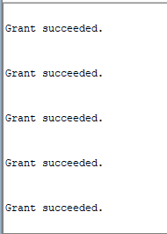grant select on modbd_bucuresti.BUCURESTI_CHIRIAS_SEQ to modbd_national;

grant select on modbd_bucuresti.BUCURESTI_ADRESA_SEQ to modbd_national;

grant select on modbd_bucuresti.BUCURESTI_APARTAMENT_SEQ to modbd_national;

grant select on modbd_bucuresti.BUCURESTI_CONTRACT_SEQ to modbd_national;

grant select on modbd_bucuresti.BUCURESTI_PLATA_CHIRIE_SEQ to modbd_national;

## Transparenta pentru fragmentele orizontale

Pentru relatiile  **OLTP_JUDET** si **OLTP_LOCALITATE** am definit doar view-uri la nivel local, fara a mai defini si triggeri instead of, doarece nu se doreste modificarea tabelelor de la nivel global.

create or replace view oltp_judet

as

select * from modbd_provincie.judet_provincie@bd_provincie

union all

select * from modbd_bucuresti.judet_bucuresti;

create or replace view oltp_localitate

as

select * from modbd_provincie.localitate_provincie@bd_provincie

union all

select * from modbd_bucuresti.localitate_bucuresti;

Transparenta pentru **OLTP_ADRESA**.

create or replace view oltp_adresa

as

select * from modbd_provincie.adresa_provincie@bd_provincie

union all

select * from modbd_bucuresti.adresa_bucuresti;

A fost creat un trigger instead of insert or update or delete pentru view-ul creat pentru a mentine ideea ca utilizatorul interactioneaza cu o singura entitate.



CREATE OR REPLACE TRIGGER t_adresa

INSTEAD OF INSERT OR UPDATE OR DELETE ON oltp_adresa

FOR EACH ROW

DECLARE

v_in_bucuresti NUMBER := 0;

BEGIN

select count (*) into v_in_bucuresti from modbd_bucuresti.localitate_bucuresti loc

join modbd_bucuresti.judet_bucuresti jud on loc.id_judet = jud.id_judet

where id_localitate = :new.id_localitate AND jud.nume = 'Bucuresti';

if v_in_bucuresti = 0 then

IF INSERTING THEN

BEGIN

INSERT INTO adresa_provincie@bd_provincie VALUES (PROVINCIE_ADRESA_SEQ.NEXTVAL@bd_provincie, :NEW.strada, :NEW.numar, :NEW.bloc, :NEW.scara, :NEW.numar_apartament, :NEW.id_localitate);

EXCEPTION

WHEN DUP_VAL_ON_INDEX THEN

NULL; -- Înregistrarea există deja, nu se face nimic

END;

ELSIF UPDATING THEN

UPDATE adresa_provincie@bd_provincie SET id_adresa = :NEW.id_adresa, strada = :NEW.strada, numar = :NEW.numar, bloc = :NEW.bloc, scara = :NEW.scara, numar_apartament = :NEW.numar_apartament, id_localitate = :NEW.id_localitate

WHERE id_adresa = :NEW.id_adresa AND (strada <> :NEW.strada OR numar <> :NEW.numar OR bloc <> :NEW.bloc OR scara <> :NEW.scara OR numar_apartament <> :NEW.numar_apartament OR id_localitate <> :NEW.id_localitate ) ;

ELSIF DELETING THEN

DELETE FROM adresa_provincie@bd_provincie WHERE id_adresa = :OLD.id_adresa;

END IF;

else

IF INSERTING THEN

BEGIN

INSERT INTO modbd_bucuresti.adresa_bucuresti VALUES (modbd_bucuresti.BUCURESTI_ADRESA_SEQ.NEXTVAL, :NEW.strada, :NEW.numar, :NEW.bloc, :NEW.scara, :NEW.numar_apartament, :NEW.id_localitate);

EXCEPTION

WHEN DUP_VAL_ON_INDEX THEN

NULL; -- Înregistrarea există deja, nu se face nimic

END;

ELSIF UPDATING THEN

UPDATE modbd_bucuresti.adresa_bucuresti SET id_adresa = :NEW.id_adresa, strada = :NEW.strada, numar = :NEW.numar, bloc = :NEW.bloc, scara = :NEW.scara, numar_apartament = :NEW.numar_apartament, id_localitate = :NEW.id_localitate

WHERE id_adresa = :NEW.id_adresa AND (strada <> :NEW.strada OR numar <> :NEW.numar OR bloc <> :NEW.bloc OR scara <> :NEW.scara OR numar_apartament <> :NEW.numar_apartament OR id_localitate <> :NEW.id_localitate ) ;

ELSIF DELETING THEN

DELETE FROM modbd_bucuresti.adresa_bucuresti WHERE id_adresa = :OLD.id_adresa;

END IF;

end if;

END;

Transaparenta pentru **OLTP_APARTAMENT.**

create or replace view oltp_apartament

as

select * from modbd_provincie.apartament_provincie@bd_provincie

union all

select * from modbd_bucuresti.apartament_bucuresti;

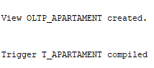

CREATE OR REPLACE TRIGGER t_apartament

INSTEAD OF INSERT OR UPDATE OR DELETE ON oltp_apartament

FOR EACH ROW

DECLARE

v_in_bucuresti NUMBER := 0;

BEGIN

select count (*) into v_in_bucuresti from modbd_bucuresti.adresa_bucuresti adr

join modbd_bucuresti.localitate_bucuresti loc on adr.id_localitate = loc.id_localitate

join modbd_bucuresti.judet_bucuresti jud on loc.id_judet = jud.id_judet

where adr.id_adresa = :NEW.id_adresa AND jud.nume = 'Bucuresti';

if v_in_bucuresti = 0 then

IF INSERTING THEN

BEGIN

INSERT INTO apartament_provincie@bd_provincie VALUES (PROVINCIE_APARTAMENT_SEQ.NEXTVAL@bd_provincie, :NEW.id_adresa, :NEW.numar_camere, :NEW.etaj, :NEW.suprafata, :NEW.centrala_proprie, :NEW.pret_inchiriere, :NEW.tip_confort);

EXCEPTION

WHEN DUP_VAL_ON_INDEX THEN

NULL; -- Înregistrarea există deja, nu se face nimic

END;

ELSIF UPDATING THEN

UPDATE apartament_provincie@bd_provincie SET id_adresa = :NEW.id_adresa, numar_camere = :NEW.numar_camere, etaj = :NEW.etaj, suprafata = :NEW.suprafata, centrala_proprie = :NEW.centrala_proprie, pret_inchiriere = :NEW.pret_inchiriere, tip_confort = :NEW.tip_confort

WHERE id_apartament = :NEW.id_apartament AND (id_adresa <> :NEW.id_adresa OR numar_camere <> :NEW.numar_camere OR etaj <> :NEW.etaj OR suprafata <> :NEW.suprafata OR centrala_proprie <> :NEW.centrala_proprie OR pret_inchiriere <> :NEW.pret_inchiriere OR tip_confort <> :NEW.tip_confort ) ;

ELSIF DELETING THEN

DELETE FROM apartament_provincie@bd_provincie WHERE id_apartament = :OLD.id_apartament;

END IF;

else

IF INSERTING THEN

BEGIN

INSERT INTO modbd_bucuresti.apartament_bucuresti VALUES (modbd_bucuresti.BUCURESTI_APARTAMENT_SEQ.NEXTVAL, :NEW.id_adresa, :NEW.numar_camere, :NEW.etaj, :NEW.suprafata, :NEW.centrala_proprie, :NEW.pret_inchiriere, :NEW.tip_confort);

EXCEPTION

WHEN DUP_VAL_ON_INDEX THEN

NULL; -- Înregistrarea există deja, nu se face nimic

END;

ELSIF UPDATING THEN

UPDATE modbd_bucuresti.apartament_bucuresti SET id_adresa = :NEW.id_adresa, numar_camere = :NEW.numar_camere, etaj = :NEW.etaj, suprafata = :NEW.suprafata, centrala_proprie = :NEW.centrala_proprie, pret_inchiriere = :NEW.pret_inchiriere, tip_confort = :NEW.tip_confort

WHERE id_apartament = :NEW.id_apartament AND (id_adresa <> :NEW.id_adresa OR numar_camere <> :NEW.numar_camere OR etaj <> :NEW.etaj OR suprafata <> :NEW.suprafata OR centrala_proprie <> :NEW.centrala_proprie OR pret_inchiriere <> :NEW.pret_inchiriere OR tip_confort <> :NEW.tip_confort ) ;

ELSIF DELETING THEN

DELETE FROM modbd_bucuresti.apartament_bucuresti WHERE id_apartament = :OLD.id_apartament;

END IF;

end if;

END;

/

Transaparenta pentru **OLTP_CONTRACT.**

create or replace view oltp_CONTRACT

as

select * from modbd_provincie.contract_provincie@bd_provincie

union all

select * from modbd_bucuresti.contract_bucuresti;

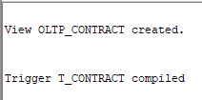

CREATE OR REPLACE TRIGGER t_contract

INSTEAD OF INSERT OR UPDATE OR DELETE ON oltp_CONTRACT

FOR EACH ROW

DECLARE

v_in_bucuresti NUMBER := 0;

BEGIN

select count (*) into v_in_bucuresti from modbd_bucuresti.apartament_bucuresti ap

join modbd_bucuresti.adresa_bucuresti adr on ap.id_adresa = adr.id_adresa

join modbd_bucuresti.localitate_bucuresti loc on adr.id_localitate = loc.id_localitate

join modbd_bucuresti.judet_bucuresti jud on loc.id_judet = jud.id_judet

where ap.id_apartament = :new.id_apartament AND jud.nume = 'Bucuresti';

if v_in_bucuresti = 0 then

IF INSERTING THEN

BEGIN

INSERT INTO contract_provincie@bd_provincie VALUES (PROVINCIE_CONTRACT_SEQ.NEXTVAL@bd_provincie, :NEW.id_chirias, :NEW.id_apartament, :NEW.id_agent, :NEW.data_inceput, :NEW.data_final, :NEW.ziua_scadenta, :NEW.pret_inchiriere, :NEW.valoare_estimata, :NEW.incasari);

EXCEPTION

WHEN DUP_VAL_ON_INDEX THEN

NULL; -- Înregistrarea există deja, nu se face nimic

END;

ELSIF UPDATING THEN

UPDATE contract_provincie@bd_provincie SET id_chirias = :NEW.id_chirias, id_apartament = :NEW.id_apartament, id_agent = :NEW.id_agent, data_inceput = :NEW.data_inceput, data_final = :NEW.data_final, ziua_scadenta = :NEW.ziua_scadenta, pret_inchiriere = :NEW.pret_inchiriere, valoare_estimata = :NEW.valoare_estimata, incasari = :NEW.incasari

WHERE id_contract = :NEW.id_contract AND (id_chirias <> :NEW.id_chirias OR id_apartament <> :NEW.id_apartament OR id_agent <> :NEW.id_agent OR data_inceput <> :NEW.data_inceput OR data_final <> :NEW.data_final OR ziua_scadenta <> :NEW.ziua_scadenta OR pret_inchiriere <> :NEW.pret_inchiriere OR valoare_estimata <> :NEW.valoare_estimata OR incasari <> :NEW.incasari ) ;

ELSIF DELETING THEN

DELETE FROM contract_provincie@bd_provincie WHERE id_contract = :OLD.id_contract;

END IF;

else

IF INSERTING THEN

BEGIN

INSERT INTO modbd_bucuresti.contract_bucuresti VALUES (modbd_bucuresti.BUCURESTI_CONTRACT_SEQ.NEXTVAL, :NEW.id_chirias, :NEW.id_apartament, :NEW.id_agent, :NEW.data_inceput, :NEW.data_final, :NEW.ziua_scadenta, :NEW.pret_inchiriere, :NEW.valoare_estimata, :NEW.incasari);

EXCEPTION

WHEN DUP_VAL_ON_INDEX THEN

NULL; -- Înregistrarea există deja, nu se face nimic

END;

ELSIF UPDATING THEN

UPDATE modbd_bucuresti.contract_bucuresti SET id_chirias = :NEW.id_chirias, id_apartament = :NEW.id_apartament, id_agent = :NEW.id_agent, data_inceput = :NEW.data_inceput, data_final = :NEW.data_final, ziua_scadenta = :NEW.ziua_scadenta, pret_inchiriere = :NEW.pret_inchiriere, valoare_estimata = :NEW.valoare_estimata, incasari = :NEW.incasari

WHERE id_contract = :NEW.id_contract AND (id_chirias <> :NEW.id_chirias OR id_apartament <> :NEW.id_apartament OR id_agent <> :NEW.id_agent OR data_inceput <> :NEW.data_inceput OR data_final <> :NEW.data_final OR ziua_scadenta <> :NEW.ziua_scadenta OR pret_inchiriere <> :NEW.pret_inchiriere OR valoare_estimata <> :NEW.valoare_estimata OR incasari <> :NEW.incasari ) ;

ELSIF DELETING THEN

DELETE FROM modbd_bucuresti.contract_bucuresti WHERE id_contract = :OLD.id_contract;

END IF;

end if;

END;

/

Transaparenta pentru **OLTP_PLATA_CHIRIE.**

create or replace view oltp_plata_chirie

as

select * from modbd_provincie.plata_chirie_provincie@bd_provincie

union all

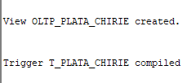select * from modbd_bucuresti.plata_chirie_bucuresti;

CREATE OR REPLACE TRIGGER t_plata_chirie

INSTEAD OF INSERT OR UPDATE OR DELETE ON oltp_plata_chirie

FOR EACH ROW

DECLARE

v_in_bucuresti NUMBER := 0;

BEGIN

select count (*) into v_in_bucuresti from modbd_bucuresti.contract_bucuresti c

join modbd_bucuresti.apartament_bucuresti ap on c.id_apartament = ap.id_apartament

join modbd_bucuresti.adresa_bucuresti adr on ap.id_adresa = adr.id_adresa

join modbd_bucuresti.localitate_bucuresti loc on adr.id_localitate = loc.id_localitate

join modbd_bucuresti.judet_bucuresti jud on loc.id_judet = jud.id_judet

where c.id_contract = :new.id_contract AND jud.nume = 'Bucuresti';

if v_in_bucuresti = 0 then

IF INSERTING THEN

BEGIN

INSERT INTO plata_chirie_provincie@bd_provincie VALUES (PROVINCIE_PLATA_CHIRIE_SEQ.NEXTVAL@bd_provincie, :NEW.id_contract, :NEW.luna, :NEW.an, :NEW.suma, :NEW.data_efectuarii, :NEW.nr_zile_intarziere);

EXCEPTION

WHEN DUP_VAL_ON_INDEX THEN

NULL; -- Înregistrarea există deja, nu se face nimic

END;

ELSIF UPDATING THEN

UPDATE plata_chirie_provincie@bd_provincie SET id_contract = :NEW.id_contract, luna = :NEW.luna, an = :NEW.an, suma = :NEW.suma, data_efectuarii = :NEW.data_efectuarii, nr_zile_intarziere = :NEW.nr_zile_intarziere

WHERE id_plata = :NEW.id_plata AND (id_contract <> :NEW.id_contract OR luna <> :NEW.luna OR an <> :NEW.an OR suma <> :NEW.suma OR data_efectuarii <> :NEW.data_efectuarii OR nr_zile_intarziere <> :NEW.nr_zile_intarziere) ;

ELSIF DELETING THEN

DELETE FROM plata_chirie_provincie@bd_provincie WHERE id_plata = :OLD.id_plata;

END IF;

else

IF INSERTING THEN

BEGIN

INSERT INTO modbd_bucuresti.plata_chirie_bucuresti VALUES (modbd_bucuresti.BUCURESTI_PLATA_CHIRIE_SEQ.NEXTVAL, :NEW.id_contract, :NEW.luna, :NEW.an, :NEW.suma, :NEW.data_efectuarii, :NEW.nr_zile_intarziere);

EXCEPTION

WHEN DUP_VAL_ON_INDEX THEN

NULL; -- Înregistrarea există deja, nu se face nimic

END;

ELSIF UPDATING THEN

UPDATE modbd_bucuresti.plata_chirie_bucuresti SET id_contract = :NEW.id_contract, luna = :NEW.luna, an = :NEW.an, suma = :NEW.suma, data_efectuarii = :NEW.data_efectuarii, nr_zile_intarziere = :NEW.nr_zile_intarziere

WHERE id_plata = :NEW.id_plata AND (id_contract <> :NEW.id_contract OR luna <> :NEW.luna OR an <> :NEW.an OR suma <> :NEW.suma OR data_efectuarii <> :NEW.data_efectuarii OR nr_zile_intarziere <> :NEW.nr_zile_intarziere) ;

ELSIF DELETING THEN

DELETE FROM modbd_bucuresti.plata_chirie_bucuresti WHERE id_plata = :OLD.id_plata;

END IF;

end if;

END;

/

# Asigurarea sincronizării datelor pentru relațiile replicate

Relatia **OLTP_CHIRIAS** a fost replicata, asta inseamna ca trebuie sa avem tot tabelul in ambele baze de date, atat in BUCURESTI cat si in PROVINCIE.

Au fost definit urmatori triggeri:

**Provincie**

CREATE OR REPLACE TRIGGER trig_rep_chirias

AFTER INSERT OR UPDATE OR DELETE ON chirias

FOR EACH ROW

DECLARE

v_dummy NUMBER;

BEGIN

IF INSERTING THEN

BEGIN

INSERT INTO CHIRIAS@bd_bucuresti VALUES (:NEW.id_chirias, :NEW.prenume, :NEW.nume, :NEW.telefon, :NEW.email, :NEW.sex, :NEW.data_nastere, :NEW.starea_civila);

EXCEPTION

WHEN DUP_VAL_ON_INDEX THEN

NULL; -- Înregistrarea există deja, nu se face nimic

END;

ELSIF UPDATING THEN

UPDATE CHIRIAS@bd_bucuresti SET prenume = :NEW.prenume, nume = :NEW.nume, telefon = :NEW.telefon, email = :NEW.email, sex = :NEW.sex, data_nastere = :NEW.data_nastere, starea_civila = :NEW.starea_civila

WHERE id_chirias = :NEW.id_chirias AND (prenume <> :NEW.prenume OR nume <> :NEW.nume OR telefon <> :NEW.telefon OR email <> :NEW.email OR sex <> :NEW.sex OR data_nastere <> :NEW.data_nastere OR starea_civila <> :NEW.starea_civila );

ELSIF DELETING THEN

DELETE FROM CHIRIAS@bd_bucuresti WHERE id_chirias = :OLD.id_chirias;

END IF;

END;

/

**Bucuresti**

CREATE OR REPLACE TRIGGER trig_rep_chirias_bucuresti

AFTER INSERT OR UPDATE OR DELETE ON chirias

FOR EACH ROW

DECLARE

 v_dummy NUMBER;

BEGIN

IF INSERTING THEN

BEGIN

INSERT INTO CHIRIAS@bd_provincie VALUES (:NEW.id_chirias, :NEW.prenume, :NEW.nume, :NEW.telefon, :NEW.email, :NEW.sex, :NEW.data_nastere, :NEW.starea_civila);

EXCEPTION

WHEN DUP_VAL_ON_INDEX THEN

NULL; -- Înregistrarea există deja, nu se face nimic

END;

ELSIF UPDATING THEN

UPDATE CHIRIAS@bd_provincie SET prenume = :NEW.prenume, nume = :NEW.nume, telefon = :NEW.telefon, email = :NEW.email, sex = :NEW.sex, data_nastere = :NEW.data_nastere, starea_civila = :NEW.starea_civila

WHERE id_chirias = :NEW.id_chirias AND (prenume <> :NEW.prenume OR nume <> :NEW.nume OR telefon <> :NEW.telefon OR email <> :NEW.email OR sex <> :NEW.sex OR data_nastere <> :NEW.data_nastere OR starea_civila <> :NEW.starea_civila ) ;

ELSIF DELETING THEN

DELETE FROM CHIRIAS@bd_provincie WHERE id_chirias = :OLD.id_chirias;

END IF;

END;

/

# Asigurarea constrângerilor de integritate

Pentru a pastra constrangerile de integritate pe adresa apartamentului am definit doi triggeri before insert in fiecare baza de date locala.

**Bucuresti**

create or replace trigger trigger_apartament_adr_unique

before insert or update on ADRESA_BUCURESTI

for each row

declare

nr number(1);

begin

select count(*) into nr

from ADRESA_PROVINCIE@bd_provincie

where STRADA = :NEW.STRADA AND NUMAR = :NEW.NUMAR AND BLOC = :NEW.BLOC AND SCARA = :NEW.SCARA AND NUMAR_APARTAMENT = :NEW.NUMAR_APARTAMENT;

if (nr<>0) then

raise_application_error (-20001,'Constangere de unicitate pe adresa

incalcata.');

end if;

end;

/

**Provincie**

create or replace trigger trigger_apartament_adr_unique

before insert or update on ADRESA_PROVINCIE

for each row

declare

nr number(1);

begin

select count(*) into nr

from ADRESA_BUCURESTI@bd_bucuresti

where STRADA = :NEW.STRADA AND NUMAR = :NEW.NUMAR AND BLOC = :NEW.BLOC AND SCARA = :NEW.SCARA AND NUMAR_APARTAMENT = :NEW.NUMAR_APARTAMENT;

if (nr<>0) then

raise_application_error (-20001,'Constangere de unicitate pe adresa incalcata.');

end if;

end;

/